Description on how to download futures Market data (all contracts) from INO.com Exchanges:

While this example shows how to downloadd last-trade “Livestock and Meat” market data, the design is made generic enough to download all the other futures market data from this same web page:
http://quotes.ino.com/exchanges/?r=CME_FC

Set-up:

- Copy the following line and append to your existing “mywebserver.txt”, or simply substitute it the attached “mywebserver.txt”.

Futures_ALL_INO_XXXX,http://quotes.ino.com/exchanges/?r=XXXX,L3,Futures_INO_L3.fmt

- Replace the “Futures_INO_L3.fmt” file in the “fmt” subfolder with the attached version (the old one does not work any more).
- Run HSQuote Plus and set up the screen as soon. Please note that the portfolio name should be “Futures_ALL_INO_CME_FC.tic” because the line added in the “mywebserver.txt” is “Futures_ALL_INO_XXXX” where the XXXX is generic to accept other portfolios, such as “Futures_ALL_INO_CME_PB.tic” for frozen pork bellies, etc.

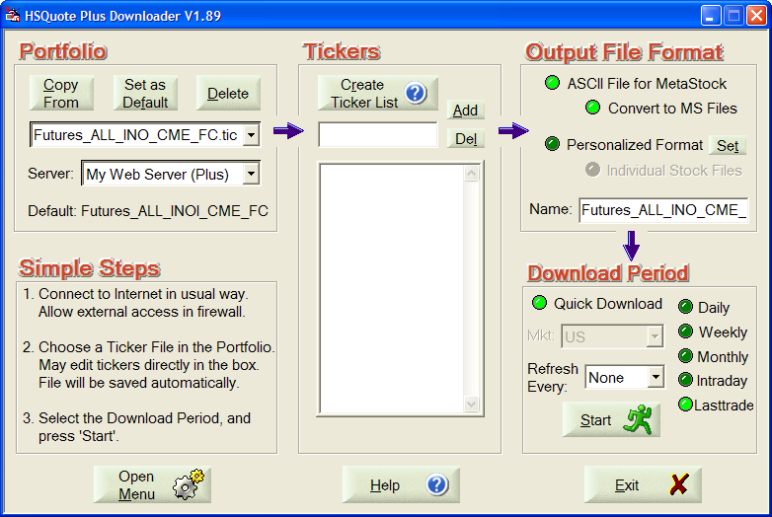

Note that in the Tickers List, we do NOT need to enter all the symbols on the web page http://quotes.ino.com/exchanges/?r=CME_FC as shown below. The trick is that in the “Futures_INO_L3.fmt” file, we have added a line:
1@myRenewTickers#Renew Ticker List before download (default: 0, No)
This line tells the program to always renew the ticker list before downloading new data. Of course, you may choose to manually enter the symbols and delete this line ☺.

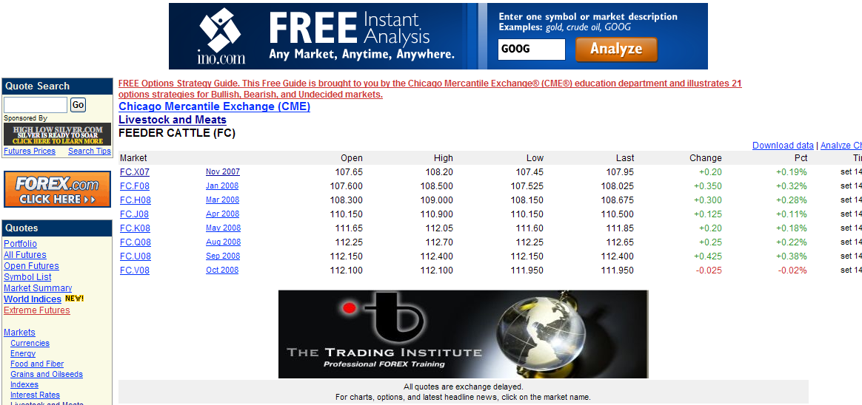

Last-Trade Daily Data Download:

This web page refreshes the last-trade data regularly. You may download in the middle of the session or at the end of the day. Please note that the data will carry the date that the download is done. So you need to do the download on the same day. You may set up the Microsoft Task Scheduler to download data on a fixed schedule.

